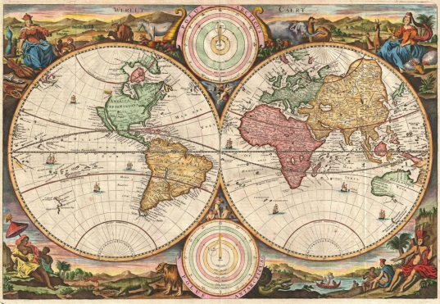
The Mapmaker’s Tent
GEOGRAPHY Workshop

Packing Our Bags
Genesis 1
Project: Exploring Maps
Materials: Variety of Maps (puzzles, globes, books); Blue Construction Paper, Map cutouts
Concept: The whole earth is God’s creation. We will explore the vastness of God’s creation by looking at the many countries, types of land, and oceans that make up earth.

Gathering/Demonstration
As students enter the space, gather them in a seated circle.

Read (or invite a volunteer to read) Genesis 1.

Ask, “What do you think this story is trying to teach us?” Allow everyone a chance to answer. Say, “The stories of Creation in the Bible teach us that the whole earth, and everything in it, is God’s. God loves and cares for all of the places, plants, animals, oceans, trees, and most importantly people in the world.”

Hold up a globe. Say, “The earth is 260 billion cubic miles. In other words – it’s huge! And just like the creation story says, it is covered in a wide variety of plants and animals, rocks and land formations, oceans and seas – and people! This year in Sunday school we are going to travel around the earth to learn more about how God’s people understand and interact with God. Before we go, we need to be sure we know where we are going.” Explain that this morning we are going to do a variety of activities that help us to take a look at the earth. Say, “Before you head off on a trip it is important to look at the map to know where you are going. Today we are going to look at maps, build maps, draw/color maps, and more.”
Map-sloration
Divide the class in to two groups. The groups will take turns doing the puzzle and map-making activities.
Activity 1: Map Puzzle
Have students work as a group to put together a map puzzle. There are age-appropriate puzzles for older and younger children. Once they have completed the map, spend a few minutes talking about the map: identify continents and oceans, point out large countries, talk about different languages spoken around the world.
Activity 2: Making Maps
Give each child a sheet of blue paper and a collection of “map cutouts.” (In older classes students can cut out their own pieces. Precut pieces are available for younger children.) Hang a printed map where it can easily be seen. Help students to recreate the map by gluing the cutouts to the blue paper. These maps will be added to the passports they are making in another workshop this month.
Catch that Creation!
Spread around the room. For this game, a large inflatable earth will serve as the ball in a game of educational catch.
Say, “Before you throw the ball, call out the name of the friend that you are throwing it to. When you catch the ball, it is your turn to name ___________________.”
There are two versions of this game. In younger classes, have students name something in creation when they catch the ball (animals, plants, people, mountains, etc). In older classes, students name a country when they catch a ball. Try not to repeat an answer that has already been given!
Ready to Go!
In the final moments of class, bring the group back together in a seated circle. Spend a few minutes discussing how the people and places in creation are all very different, but also have many things in common.
Read Colossians 1:16.
Say, “Most importantly, we are all loved by God and all called to share God’s love with one another. Jesus commands us to love our neighbors. All of the people on our maps and globe are our neighbors.”
Clean Up
Work as a group to tidy up the classroom. Return all materials to the Youth Room following worship.

