Creation Station
ART WORKSHOP

Packing Our Bags
Genesis 1:26-30; Colossians 1:16
Project: Passports
Materials: Blank books, Duct Tape, Markers/Crayons, Scissors, “Passport” sheets
Concept: Passports allow us to travel the world. They also serve as a “memory book” of the places we have been. Our passports will help us to record the places that we visit and the faith lessons that we learn throughout the year.

Gathering/Demonstration
As students enter the space, gather them in a seated circle at the table. Say, “This year we will be traveling around the world in Sunday school! Each month we will visit a new country. While we are there, we will talk about an important piece of our faith. We will learn about how some of the people in other parts of the world practice their faith. We will learn about how people pray in Palestine, how people help one another in Israel, how people ask God for forgiveness in Greece, and more!”

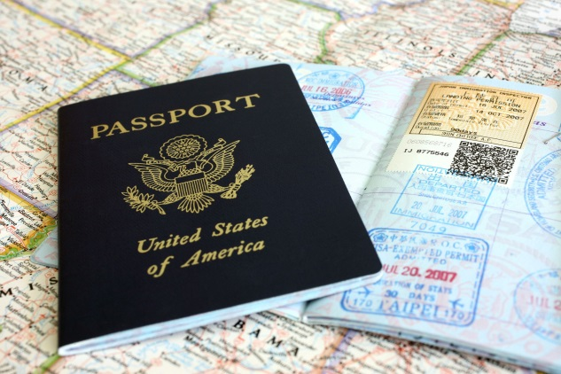
Ask, “Have any of you ever been to other countries?” Spend a few moments talking about experiences that children may have had visiting other countries or cultures. Did they try new food? Hear different languages being spoken? See people wearing different types of clothing or hairstyles?

Read (or invite a volunteer to read) Genesis 1:26-30. Say, “Scripture tells us that we are all made in the image and likeness of God. All of the people on earth – no matter where they live, what they look like, or what they believe – are God’s children. This year we are going to get to know a little bit more about God’s children. We are going to see that while there may be ways that we are different, in many ways we are alike.
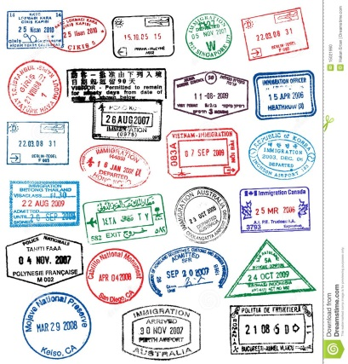
Hold up a real passport. Allow the children to take a look at the pages inside. Say, “When we travel to other countries, we need a passport. A passport has information about who we are and where we are from. When we enter a new country we get a stamp in our passport. A passport is both a form of identification and a memory book of all of the places that you travel to.”

Explain that this morning we will be making our own passports. We will start by creating a page of information all about ourselves. We will then decorate our passports so that we know who they belong to. Each time we visit a new country, we will add a page of information about that country and about what we learn about our faith while we are there. At the end of the year we will have created a memory book of our travels and the things that we did and learned.

Passport Data Page
Open the real passport to the Passport Data Page. Allow the children to take a look. Ask, “What kind of information is on a Passport Data Page?”
Say, “In a real passport, the Passport Data Page contains information about a person including where they are from, their birthdate, and what they look like. This is important information for identifying someone. The passports we are making this morning are a little different. Our passports are for spiritual travel. Instead of including information about where we come from or when we are born, we are going to include information about what we believe. “
Give each child a Passport Data Page and a small square of paper. Have them draw a self portrait on the paper square and affix it to the PDP. In older classes, students should write the answers to the questions on the PDP. Help younger students to write their names and answers. Then, pass out blank books. Help children to glue their PDP to the first page of their book.
Making it Mine
Passports are a very personal and unique thing – just like our faith! Throughout the year our passports will serve as a place to record important things that we learn and faith developments that help us to better understand our relationship with God.
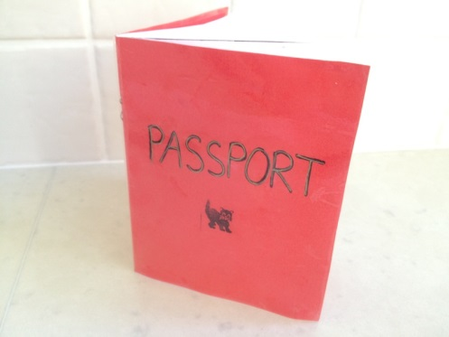
Set out a variety of materials (duct tape, markers, construction paper, etc) for students to decorate their passports. Say, “Your passport, just like your faith, is something that is unique and special. Decorate your passport to tell a story about who you are, what you like, what your believe, etc.”
While students work, spend a few moments talking about the take-away message for the month: all people are God’s children, created in God’s image and likeness. Discuss the following:
- How do you think God wants us to treat God’s children?
- Do parents love some of their children more than others? Does God love some people more than others?
Clean Up
Work as a group to tidy up the classroom. Return all materials to the Youth Room following worship.

