BIBLE 101
Unit 2: Building Our Lives on God
Jonah – God Has a Purpose For Us
A Note to the Teacher: There is a little bit of Jonah in each of us. How often do we get frustrated, or even angry, with those who are always making poor choices? Or, even worse, those who have wronged us in some way? And yet God wants us to help them? You have got to be kidding me! The story of Jonah is one of hearing God’s call and, though it may be uncomfortable or frustrating, trusting that God has a purpose for us.
In many churches, the word “obedience” comes up around the story of Jonah. This is not a bad word, but can be a dangerous one if not explained carefully. When we talk about being obedient to God, we are talking about living a life that reflects God’s love and grace. Jonah was obedient when he want to Nineveh despite his own reservations. We are obedient to God when we love and care for God’s people despite our differences and prejudices.
Gathering
As students enter the space, gather them in a seated circle. Move from student to student, whispering to them individually a silly command. (ie “Put your hand on your head and stick out your tongue. Hold it until I say stop.”) When you have given everyone a command, return to the front of the room and see how many students are doing as they were asked.
Say, “I gave each of you a different command. It looks like not all of you chose to do as I asked!” Pretend to be very disappointed, almost sad. Say, “I was hoping you would get to see the cool thing we made, but oh well. I guess it is hard to do something you don’t want to do, especially if you don’t know why you are doing it.”
Release those who are holding their silly poses.
Say, “Today, we are going to talk about someone else who had a hard time following a command. This command was a little bigger than striking a silly pose, and the consequences of not doing it were much bigger than a disappointed teacher.”
For grades 2-5, have students turn to Jonah in their Bibles. For prek-grade 1, open the teacher’s Bible to Jonah. Younger classes will want to read from the Bible Storybook.
Say, “I am going to guess almost all of you have heard of a man named Jonah before. What do you know about Jonah?” Give time for answers.
Say, “There is something strange about Jonah. Jonah is most famous for what went wrong when he didn’t listen to God. But by reading about what happens to Jonah when he does not obey God, we can learn a lot about the purpose that God has for us and how important it is to listen to God in our own lives.
In grades 2-5, read or invite volunteers to read Jonah 1:1-7, 2:1-10, 3:1-10. In preschool-grade 1, read the illustrated story of Jonah and the Big Fish.
Say, “Jonah was a prophet, a messenger for God. In the Old Testament we read a lot about prophets who would receive messages from God and then share them with the world. Jonah had spent his life traveling from town to town sharing messages from God about love and forgiveness and hope. God would speak to Jonah and tell him where to go, and Jonah would pack his things and travel to where God directed him. Until the day that God asked Jonah to go to Nineveh. Jonah knew that the people in Nineveh were extremely unkind. They were always at war. Nineveh was a dangerous place. When God asked Jonah to go to Nineveh, Jonah was scared. Would he be arrested or even killed if he went there? He was certain no one would listen to his message of love and kindness. There was NO WAY Jonah was going to Nineveh!”
Ask, “So what did Jonah do?”
Say, “Jonah tried to run away from God’s command to go to Nineveh. He tried to sail himself in the opposite direction. But God had a plan for Jonah, and nothing Jonah did was going to stop that plan. God sends the fish to swallow Jonah. And while Jonah sits for three days in the belly of the fish, God talks to Jonah. Jonah prays, and God reminds Jonah that he is created with a purpose: to share God’s message of love with the world. Not only when it is fun, but all of the time. Not only when it is easy, but especially when it is hard.”
Spend some time discussing the story with age-appropriate questions:
Preschool-Grade 1:
- What happens to Jonah after three days in the fish?
- Where does Jonah go after he is spit out?
- What happens when Jonah gets to Nineveh?
Grades 2-5:
- Has God ever asked you to do something uncomfortable?
- Where is the Nineveh in your life? Whom does God ask you to help that you do not want to help?
- Do you think a man really spent three days inside a fish? If it isn’t true, why do you think this story is in the Bible?
Man-Eating Fish
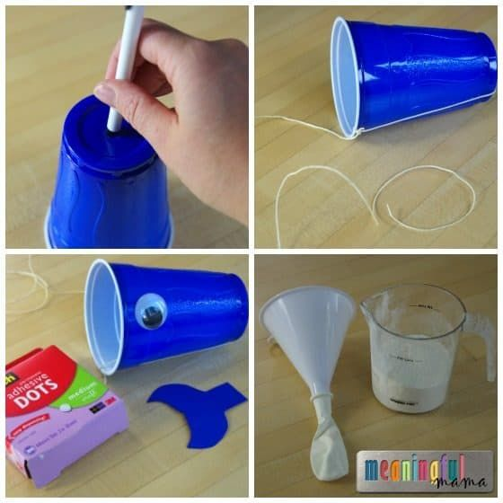
Say, “The story of Jonah could be the story of any one of us. God asks us to do something and, for one reason or another, we don’t want to. And so we try to hide from God’s purpose for our lives. Thankfully, God doesn’t send giant fish to swallow us, but God does send reminders. God keeps asking, over and over, for us to be God’s people. God had a purpose for Jonah’s life, and was determined that Jonah was going to do what God needed him to do. God has a purpose for your life and for my life to. Our purposes are different, but God is using me and using you to love and care for God’s creation.”
Explain that this morning we are going to create a little game that will help remind us of Jonah, and of the purpose God has for our lives. It will also be a way that we can teach others about the story of Jonah and the purpose God has for their lives!
Set out blue plastic cups, googly eyes, “whale tails,” and glue. Help students transform their cups in to whales.
When everyone has added their eyes and tail, set out ballons, flour, funnels, and string. Help student put about ¼ cup of flour into a balloon and tie it off. Use a sharpie marker to draw a little Jonah on the balloons. Tie a long (2ft+) piece of string to the end of the balloon and attach through the hole in the side of the whale cup.
Say, “Our balloon “Jonahs” can travel all around safely, so long as the string is not bent. But when you swing the cup just so – when the string bends and is no longer following the purpose God has for it – Jonah end up in the whale!” Demonstrate how to catch the balloon in the cup.
Spend a few moments discussing how students can use this toy to teach someone else the story of Jonah this week.
Closing/Cleanup
When everyone is finished, work as a group to clean up the classroom.

